YEAR 4  Date – September – 2 weeks |  | Here are your tasks for the next two weeks. It’s up to you what order you do them in. Enjoy and stay safe!
Language, Literacy and Communication | Language, Literacy and Communication | Language, Literacy and Communication | Maths and Numeracy | Maths and Numeracy
Listen to this story of Moses and the Ten Commandments. Discuss with your family what the commandments mean to you.  https://www.youtube.com/watch?v=LrpbfWbSbB0  Check out the Assignments Tab in the General Channel.  Find the activity selected for you. | Can you think of  5 classroom rules for your new Year 4 area  Design a poster to display your rules | This is me!  Your Year 4 teachers are really looking forward to getting to know you. Make a short video to introduce yourself!  In the literacy channel you will find a ‘help’ sheet, to help you decide what to include.  If you’re feeling a bit shy about a video, use the headings to write a fact sheet about yourself instead. | Brainteaser!  Test your knowledge!  This activity is a jigsaw puzzle of a 100 square.  Pob lwc!  https://nrich.maths.org/5572  Challenge – Try level 2.  Now:-  Create your own 100 square. You will need a ruler, paper, a pencil and colouring pencils. Use a different colour for each table. Colour multiples of 2’s in red, 3’s in blue etc. | Try this game to work out the difference between two numbers.  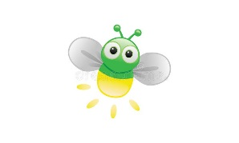  https://www.ictgames.com/mobilePage/fireFly/index.html
Maths and Numeracy | Humanities | Health and Well-being | Science and Technology | Expressive Arts
Rehearse your number bonds, doubles and halves with these great activities.  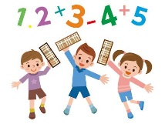  https://www.topmarks.co.uk/maths-games/hit-the-button | Use your research skills to find out about different places of worship.  This website may help you:-  http://www.primaryhomeworkhelp.co.uk/Religion.html  What are the names of the buildings and who uses them?  Are there any symbols that represent that religion?  Choose how you would like to present the information. | Have a go at this workout with  Jo Wicks.  https://www.youtube.com/watch?v=d3LPrhI0v-w  Challenge yourself to learn these Bollywood dance moves! We will look forward to seeing them in school!  https://www.youtube.com/watch?v=hpDoAr5IygI | Take part in the Science Museum ‘Great Object Hunt’.  Click on the link to see what to look out for. You can print the booklet or use it as a guide to make your own list.  https://learning.sciencemuseumgroup.org.uk/wp-content/uploads/2020/05/Science-Museum-Group-Great-Object-Hunt-Out-And-About.pdf | Origami  artists!!!  https://www.youtube.com/watch?v=M8p3h9b4wrU  Follow these instructions to make yourself a church!

