YEAR  Date – September 1st 2020 (2 weeks) |  | Here are your tasks for the next two weeks. It’s up to you what order you do them in. Enjoy and stay safe!
Language, Literacy and Communication | Language, Literacy and Communication | Language, Literacy and Communication | Maths and Numeracy | Maths and Numeracy
Brilliant Books!  We hope you have been working on your reading skills and are really interested to find out which books you have enjoyed. Write a book review about the best book you have read. There is a book review sheet in the files section in the Language and Literacy channel. | Get ready for a game!  Can you think of three facts about yourself – two that are true and one that is a trick! Try to remember them as we will be using these to play a game next week in school. | We all love to talk! But what happens when someone is talking in a story? Do you remember learning about speech marks? Use this link to remind you how they work and have a go at the quiz!  https://www.bbc.co.uk/bitesize/topics/zvwwxnb/articles/ztcp97h | Use this clip to revise the words you need when telling the time. https://www.bbc.co.uk/bitesize/articles/zsvbp4j  Now Let’s tell the time! https://mathsframe.co.uk/en/resources/resource/116/telling-the-time.  Challenge! Learn about digital time! https://www.bbc.co.uk/bitesize/topics/zkfycdm/articles/zcrmqty | Use this song to help you revise division!  https://www.bbc.co.uk/teach/supermovers/ks1-maths-division-with-mighty-red/zrh9scw  Now have a go at the division facts game! https://www.topmarks.co.uk/maths-games/hit-the-button  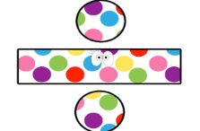
Maths and Numeracy | Science and Technology | Humanities | Health and Well-being | Expressive Arts
Have a go at this game! https://nrich.maths.org/content/id/8002/NRICH-poster_DottySix.pdf  You can watch the game being played using this link https://nrich.maths.org/7337  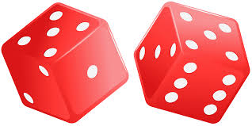 | Are you a super scientist?  Can you launch a rocket mouse? Learn about gravity and air resistance with this fun experiment. https://learning-resources.sciencemuseum.org.uk/wp-content/uploads/2019/02/SMG-Learning-Activities-Rocket-Mice.pdf | How many country’s flags do you know? Use this game to test your skills! https://world-geography-games.com/flags_europe/index.html | Let’s play dice frenzy. Using a dice can you create your own work out. Make up an exercise for numbers 1 – 6. i.e. 1 – star jumps, 2 – squats etc. Roll the dice and complete the exercise for that number – how long does it take you to role all 6 numbers? Once you have completed all 6 sit down –play with family members – who will be the first to sit down? | Our new topic is going to be Marvellous Me! Watch this clip and then have a go at drawing yourself. This is something quite tricky so you may want to have a few tries – can you improve your skills?  https://www.youtube.com/watch?v=IRp3sBQ-NFU

