YEAR 5  Date – Tuesday 1st September to Friday 11th September (2 weeks) |  | Here are your tasks for the next two weeks. It’s up to you what order you do them in. Enjoy and stay safe!
Language, Literacy and Communication | Language, Literacy and Communication | Language, Literacy and Communication | Maths and Numeracy | Maths and Numeracy
A Rainbow  Read the powerpoint and discuss it with a member of your family. (Pinned to the top in files in the LLC Channel)  Make your own information poster about rainbows, teaching others what you have learnt. | Have a go at this:  https://spellingframe.co.uk/  Year 3 and 4 Spelling Rule 36  If you don’t know the meaning of the word, look it up! | Listen to the story ‘The Knot’ by Helen Cousins being read by Mrs Morgan. Write a list of things that make you happy and calm.  https://www.youtube.com/watch?v=OuqPYelLQIg&feature=.be  Make your own Voice 21: What’s the Word? card game using the different emotions you can feel, some of which have been mentioned in the story.  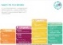  Choose a story to read to a sibling/grandparent/parent. | https://www.topmarks.co.uk/ordering-and-sequencing/coconut-ordering  Play Coconut Ordering.  Make sure you challenge yourself – there are many other different games here you can try too. | https://www.bbc.co.uk/teach/supermovers/ks2-maths-measurement-with-max-and-Harvey/zdv2cqt  You will need this information up your sleeve for Year 5 – a handy way to remember it all!  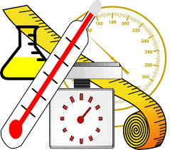
Maths and Numeracy | Science and Technology | Humanities | Health and Well-being | Expressive Arts
‘Wave your arms in the air’ with Percy Parker and learn the 8 x tables  https://www.youtube.com/watch?v=BMX8O0aGB0Q  Can you complete the booklet without looking at your 8xtables?  The booklet is pinned to the top of Files in the Maths & Numeracy channel | Grow your own rainbow!  Follow the instructions pinned to the top in files on the Science and Technology Channel.  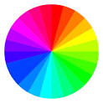 | Research at least 3 native plants from each continent. Display these in your own way on the world map provided.  (e.g. draw and label plant, print and stick picture )  Alternatively draw your own world map.  https://www.superteacherworksheets.com/maps/continents-oceans_WMZBN.pdf?up=1503417198  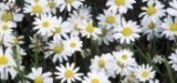 | ‘A-Z of Wellbeing after Lockdown’  Read and discuss this with someone in your house.  Which ones have you already had a go at?  Which ones could you do next?  How could you help yourself and/or someone else?  The A-Z is pinned to the top of the Health and Wellbeing Channel.  There is a blank one here too – you could make your own! | Sketch a bird step by step.  Use this video to help you improve your sketching.  https://www.youtube.com/watch?v=UMwx4raERDs  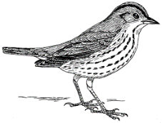  Challenge: Create a ‘Step by step’ drawing guide for a younger child to draw a bird.

