7TM 8RK  Date – Monday 29th June – Friday 17th July (3 weeks) |  | Here are your tasks for the next two weeks. It’s up to you what order you do them in. Enjoy and stay safe!
Language, Literacy and Communication | Language, Literacy and Communication | Maths and Numeracy | Maths and Numeracy
Enjoy the story of ‘What the Ladybird Heard at the Seaside’ on Seesaw.  Have you been to the seaside?  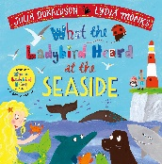 | Write a postcard and send it to us at school. Take a photo posting your postcard at the post box.  Tremains Primary School  Channel View  Brackla  Bridgend  CF31 2NL | Cut out and colour the shapes below to make a summer shape picture. What shapes have you used? | Complete the summer objects repeating pattern sheet on Seesaw.  Can you make your own pattern using household objects?  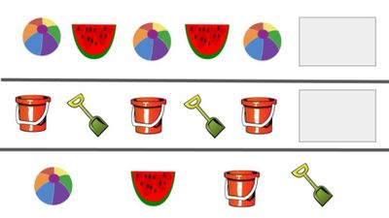
 | Humanities | Health and Well-being |  | Expressive Arts | Health and well-being
 | What doesn’t belong in the sea?  Watch the story ‘Save the Ocean’ on Seesaw.  Complete the activity, dragging all of the things that don’t belong in the sea into the rubbish bin.  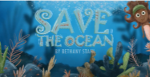 | Watch and join in with the Cosmic Kids – Squish the Fish episode.  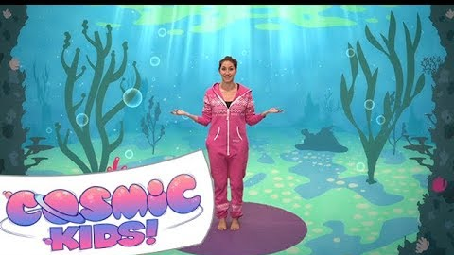 |  | Collage a beach scene. Choose some of the animals from the story to include in your picture. Have fun using lots of different things: paint, paper, sand, bubble wrap, bottle tops.  See below for some ideas. | Watch and listen to the sun safety song. Can you get dressed ready for a day out in the sunshine? What will you need to wear? Take a photo dressed and ready to go!

