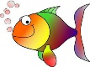  YEAR - NURSERY UNDER THE SEA!  Date – Monday 29th June to Friday 17th July (3 weeks) |  |  | Here are your tasks for the next two weeks. It’s up to you what order you do them in. Enjoy and stay safe!
Language, Literacy and Communication | 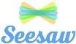  Language, Literacy and  Communication | Maths and  Numeracy |  | Maths and Numeracy | Science and Technology
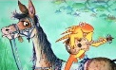  https://www.youtube.com/watch?v =n3LlN0qH0vU  Watch and listen to ‘The Fish who could Wish’ story. Now, draw a picture of one of the fish’s wishes and have a go at writing a sentence/ words/ sounds to go with the picture. (Parents- let the children have a go at sounding out words, they could copy from you or write on top of your writing- see how they go!) | 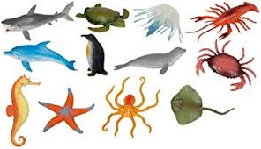  Play the ‘Who am I?’ game- think of a sea creature and describe it- your family must try to guess what you are! Then, let someone in your family have a turn and you try to guess the sea creature that they describe! | 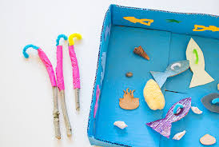  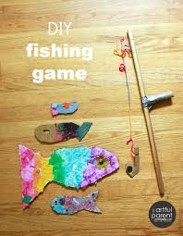  Make a fishing game- write numbers on the fish and either count who catches the most or add up their totals! |  | 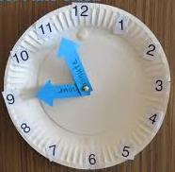  https://www.youtube.com/watch?v=hntyi-QTLJU Join in with ‘Tiddler’ story- have a go at saying the ‘o’ clock times in the story. Go on a clock hunt in your house – what can you see on the clock face?  Can you make your own clock? | https://www.youtube.com/watch? v=49o2V2TZiow  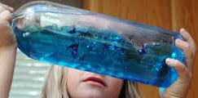  Have a go at making your own ocean in a bottle!
Science and Technology | Humanities | Expressive Arts |  | Health and Well-being | Expressive Arts
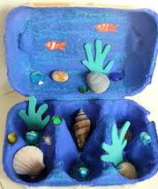  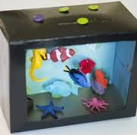  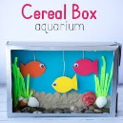  Make your own aquarium- you could use an egg box, cereal box or a shoe box! | https://www.youtube.com/watch? v=61RzwbaSoeU  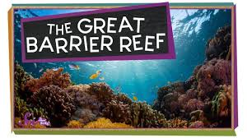  Watch the SciKids clip about The Great Barrier Reef! Find out some amazing facts! Create a collage picture/ painting of what you saw! | 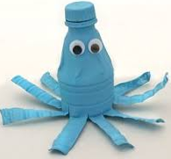  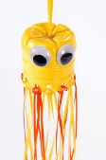  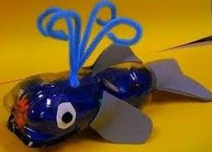  Use some of your recycling to create your own sea creature! |  | https://www.youtube.com/watch? v=LhYtcadR9nw  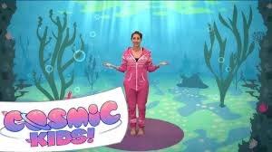  Join in with Cosmic Kids yoga- Squish the Fish! | 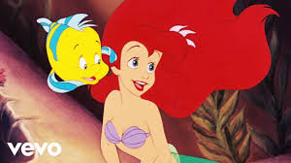  https://www.youtube.com/watch? v=GC_mV1IpjWA  Dance to ‘Under the Sea’ song!

If your child knows all of their letter sounds, they can start to learn stage 1 key words. Starting with ‘Biff’, work your way down the first column, then onto the next column and the next. This is the correct order for the children to learn their key words, which corresponds with the Oxford Reading Tree scheme. Use Oxford owl online for the children to match their key words to the books they see on screen.

to | In | Biff
went | got | Chip
was | go | Kipper

said | up | Floppy
she | you | and
day | I | Dad

can | is | Mum
look | Is | a
my | no | big

are | it | at
away | It | the
all | did | yes
come | me | get
for | see | this

cat | we | on

dog | who | in

