YEAR - RECEPTION  Date – Monday 1st June – Friday 12th June (2 weeks) |  | Here are your tasks for the next two weeks. It’s up to you what order you do them in. Enjoy and stay safe!
Language, Literacy and Communication | Language, Literacy and Communication | Maths and Numeracy | Maths and Numeracy | Science and Technology
These activities are all based on the book, ‘Superworm’. You can find the story here:  https://www.youtube.com/watch?v=7Jnk3XApKBg  Underwrite and copy a list of minibeasts – choose 6 from the book.  Remember to use the school handwriting style and pay careful attention to the size of your letters. Remember to make the tall letters taller than the others!  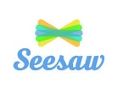 | Superworm helps lots of different friends in the story. He is very kind and caring! Discuss what this means and think of times when you have been kind and caring.  Write a kind message for the people you live with. Put the messages somewhere they will find them – what a nice surprise they will have!  You could tell them why they are so special to you or you could thank them for something they have done for you. | Length  Worms come in all different sizes.  Can you find 5 things around your home/garden and put them in length order.  You could put them from shortest to longest and label them.  What is the longest thing you can find? And the shortest? | Order  Draw a long worm and split its body into different sections.  In each section, write out numbers in order. For example, 1,2,3,4,5,6,7,8  Challenge yourself by using different start numbers and see how many number line worms you can create.  Can you start at the other end and count backwards? | Worms don’t make any noise. Can you think of other creatures that don’t make any noise?  Split a page into two – on one side place creatures that make no noise and on the other side place creatures that make noises. Can you copy the sounds they make? Can you name the sounds they make?  Which creature do you think is the loudest?  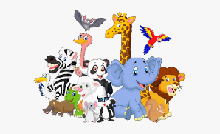
Science and Technology | Humanities | Health and Well-being | Health and Well-being | Expressive Arts
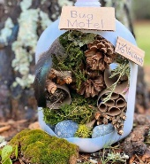  Build a bug hotel to place outside. Try to use items from your recycling or things you find outside. You can be the hotel manager and keep a look out for any new guests that might arrive! | Family Tree.  It’s time to add your grandparents! Draw a small picture of them above your parents. Add their names.  In the weeks to follow, you will be adding the rest of your family to the work.  Please keep it safe. | Keep Fit! Stay Active! Have FUN!  This week we are introducing you to some fun yoga activities. Visit the website and choose a different story to work out to each day.  https://www.cosmickids.com/category/watch/?video_category=yoga&changed=video_category | Superworm the skipping rope! How many skips can you do in 1 minute? Can a grown up time you? Check your counting! How else can you move your body like Superworm? Can you hula hoop for 1 minute? Can you use your body as a swing – swing your arms? Each day, choose different moves and see ow many you can fit into 1 minute. | Have fun creating your own worm! You could cut out a worm from card and decorate it, you could thread beads onto a string or you could make a sock worm! Get creative! You can then use your worm to retell the Superworm story or make up a story of your own.

