YEAR - NURSERY STICKS AND STONES!  Date – Monday 1st June to Friday 12th June (2 weeks) |  | Here are your tasks for the next two weeks. It’s up to you what order you do them in. Enjoy and stay safe!
Language, Literacy and Communication | 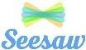  Language, Literacy and  Communication | Maths and  Numeracy | Maths and Numeracy | Science and Technology
https://www.youtube.com/watch?v=P8pKjYgjPLI Listen to the ‘Stickman’ story by Julia Donaldson, join in with ‘I’m Stickman…’ ask/ answer questions about the story throughout.  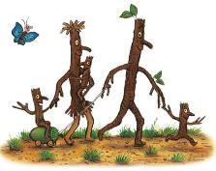  Find some twigs/ sticks and create your own Stickman/ stick family to retell the story to a member of your family. | Find some twigs/ sticks to make the letters of your name with…  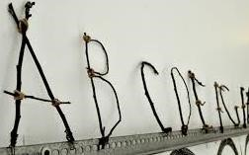 | Explore length- find sticks and stones of different sizes and put them in order of size. Measure and find the longest and shortest.  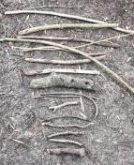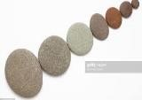 | 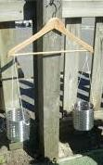  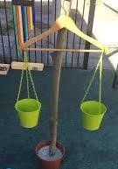  Explore heavy and light, using sticks and stones from outside!  You could make your own weighing scales | 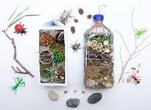  Use sticks and stones to make a bug hotel to attract more bugs into your  garden! Perhaps you could  make use of some items from your recycling!
Science and Technology | Humanities | Expressive Arts | Health and Well-being | Expressive Arts
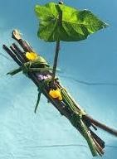  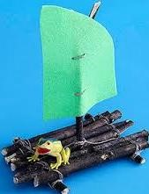  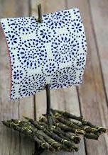  Stickman floated into the sea- can you make a stick boat that floats? | 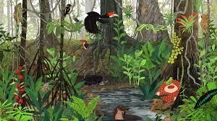  https://www.youtube.com/watch?v=KMdD6TTDZ_g Watch the ‘Explore the Rainforests’ clip on youtube. Create a rainforest painting- think about the types of trees and the different animals that live there! | Make a stick crown!  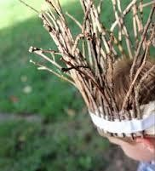  Pretend to be the King or Queen of the forest! | Make and play ‘Pick up sticks’ game using twigs. How many sticks can you pick up, without using your hands!  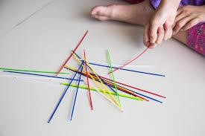 | 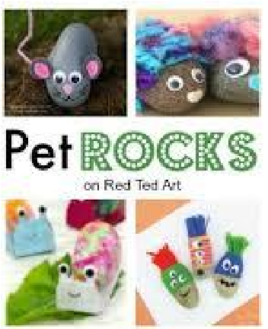  Decorate/ paint a stone to create your very own rock pet!

If your child knows all of their letter sounds, they can start to learn stage 1 key words. Starting with ‘Biff’, work your way down the first column, then onto the next column and the next. This is the correct order for the children to learn their key words, which corresponds with the Oxford Reading Tree scheme. Use Oxford owl online for the children to match their key words to the books they see on screen.

to | In | Biff
went | got | Chip
was | go | Kipper

said | up | Floppy
she | you | and
day | I | Dad

can | is | Mum
look | Is | a
my | no | big

are | it | at
away | It | the
all | did | yes
come | me | get
for | see | this

cat | we | on

dog | who | in

