YEAR 6  Date – Monday 1st to Friday 12th June (2 weeks) |  | Here are your tasks for the next two weeks. It’s up to you what order you do them in. Enjoy and stay safe!
Language, Literacy and Communication | Language, Literacy and Communication | Language, Literacy and Communication | Maths and Numeracy | Maths and Numeracy
The Spider and the Fly  Watch the animation again (Language, Literacy and Communication channel)  Create a stick puppet of the Spider and the fly. Can you re-enact the story?  Draw a comic strip retelling the story in modern language (You could use the templates provided in LLC file section or maybe download Comic Life)  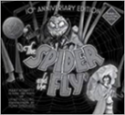 | Spider comprehension  Read the information about spiders and answer the questions that follow.  Can you attempt the THINK as well?  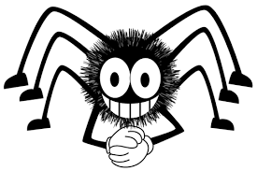  This activity has been set as an assignment so you should be able to open and edit the document to hand in. | Spelling and Grammar  Spelling rule – cious & -tious  https://www.bbc.co.uk/bitesize/topics/zt62mnb/articles/zp7dk7h  Use strategies you’ve used in your Spelling groups e.g. ‘Rainbow words’ & ‘Word Pyramids’ to learn the spellings. Can you write the word into a sentence?  THINK – can you use more than 1 word in a sentence?  See Language, Literacy and Communication channel / Files section for list of words and further instructions. | Lattice Multiplication  The ‘Lattice’ method is a popular way of multiplying numbers.  Use the link to see how the method works  https://www.youtube.com/watch?v=x2UG0YzT2UA  This activity has been set as an assignment. Challenge yourself to complete at least 2 of the 5 Lattice worksheets. | Watch, learn, tessellate!  'Maths in Nature' a Honeycomb Tessellation  https://www.youtube.com/watch?v=gNEY2okuf9U  How to Make Tessellations  https://www.youtube.com/watch?v=WBVzoaFi90E  Have fun and create your own tessellations!
Maths and Numeracy | Humanities | Health and Well-being | Science and Technology | Expressive Arts
Telling the time is an important life skill, as is being able to read and understand timetables.  Complete the ‘Comprehensive School Timetable’ worksheet and choose either 1, 2 or 3 from the ‘Reading Timetables’ and answer the time problems.  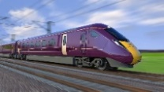  (All resources are in ‘Files’ within this Channel) | The Spider and the Fly was written in Victorian Times.  What was life like in Britain then?  Watch the Horrible Histories clips listed in the supporting materials/Assignments.  MISSION TIME – Vile Victorians  Choose one Victorian Topic to research:  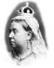  Childhood  Inventions  Famous Victorians  Think about how we present our ‘Missions’ at school and present your ideas in any creative way you want. | 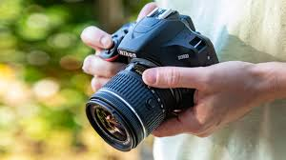  Nature is a beautiful thing and is all around us. Use the ‘Framing Nature’ document for instructions on how to capture ‘Mother Nature’ at her best!  Challenge yourself to complete the ‘Bodyweight Circuit’ every day!  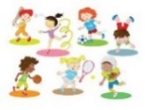  (All resources are in ‘Files’ within this Channel) | 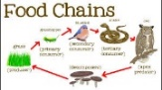  Food Chains  Read carefully through the Food Chain PowerPoint. Complete the Food Chain Worksheet – either print it out and complete, or write out the answers yourself.  (All resources in Assignments)  What food chains might you find in your garden? | 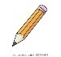  Sketching  Watch this clip about sketching techniques.  https://www.youtube.com/watch?v=7vpuA7wekN8  Practise some of these techniques then try and use some to recreate an image from the book, ‘The Spider and the Fly’.
Supporting material
Language, Literacy and Communication – Activity 3
Spelling rule – cious & -tious
https://www.bbc.co.uk/bitesize/topics/zt62mnb/articles/zp7dk7h
Use strategies you’ve used in your Spelling groups e.g. ‘Rainbow words’ & ‘Word Pyramids’ to learn the following spellings. Can you write the word into a sentence?
THINK – can you use more than 1 word in a sentence?

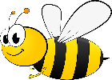
vicious
conscious
delicious
malicious
suspicious
ambitious
cautious
fictitious
infectious
nutritious
precious

