YEAR 6 - OCEANS  Date – Monday 29th June to Friday 17th July (3 weeks) |  | Here are your tasks for the next three weeks. It’s up to you what order you do them in. Enjoy and stay safe!
Language, Literacy and Communication | Language, Literacy and Communication | Language, Literacy and Communication | Maths and Numeracy | Maths and Numeracy
Activity 1  Discuss with a grown up :  - What are the 4 main plastic polluters? Research – were you correct?  - Are plastics always useful?  - Consider what impact the plastic pollution/ items could have on the environment.  Create a presentation about the dangers of plastic pollution, persuading people to reduce, reuse, recycle plastic.  This can be an oracy or written task!  This task is set as an Assignment | Activity 2  Research/ Explanation  Where and what is : The Great Pacific Trash Island?  Oracy task: Can you explain to a grown up where you will find it and how it is formed?  You decide how : Using facts from your research about identify the location and present key details about the Pacific Trash Island. https://www.nationalgeographic.org/encyclopedia/great-pacific-garbage-patch/  Think : Can you sketch the island on a world map? | Activity 3  Skimming and Scanning  Skimming and scanning are 2 very important reading skills, especially when researching specific information.  Look at the poster in LLC channel and brush up on your skimming and scanning skills by completing the file in the Language, Literacy and Communication channel | My Plastic Diary  Use the ‘My Plastic Diary’ table, saved in ‘Files’ or create your own and keep a tally of your single-use plastic use.  From your data graph your results.  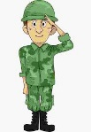  ‘SALUTE’ is used in secondary schools to ensure graphs are completed correctly, use the ‘SALUTE’ mnemonic saved in ‘Files’ to help you complete your graph correctly. | Division  The ‘Bus Stop’ method is a popular way of dividing numbers.  Use the link to see how the method works  https://www.youtube.com/watch?v=oWyTxq5mewo&list=RDCMUClIPCaVW_Cp6hcrFWHOaq-w&index=17  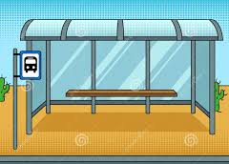  This activity has been set as an assignment. There are sums and word problems to complete.
Maths and Numeracy | Health and Well-being | Humanities | Humanities | Expressive Arts
Oceans Infograph  WHY DO THE OCEANS MATTER?  Use the example infograph to help you create your own Oceans Infograph.  Sway will be a great ‘tool’ for this activity. | Exercise Averages  Over the next 3 weeks we’d like you to be physically active on a daily basis.  You will need to work out your daily average exercise time. You can walk, jog, cycle or do any form of physical activity you like!  Achievement Level 3 Week Activity Time in Minutes  Gold 1800  Silver 1200  Bronze 600 | Oceans and Continents MISSION  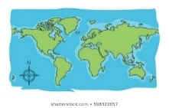  Create a learning resource pack to teach Year 5 about the oceans of the world.  This will be set as an Assignment with instructions in the General channel. | SAVE OUR OCEANS!  Follow the PowerPoint.  Watch the programme by following the link in the PowerPoint.  Then design and create a recycled sculpture with a message. | Seascape Art  Watch:  https://www.youtube.com/watch?v=U89T0FVt86E  Create your own picture.  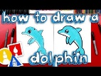  Paint or colour it too!  OR  Type into YouTube ‘How to draw a sea creature’ and copy the steps to create your sea creature art.  Copy the instructions to draw and paint/colour a range of sea creatures.

