Year 3  Date – Monday 1st to Friday 12th (2 weeks) |  | Here are your tasks for the next two weeks.  It’s up to you what order you do them in. Enjoy and stay safe!
Language, Literacy and Communication | Language, Literacy and Communication | Language, Literacy and Communication | Maths and Numeracy | Maths and Numeracy
This short song introduces you to the oceans of the world – Enjoy!  Five Oceans Song/Five Oceans of the World - YouTube  www.youtube.com › watch  Write fascinating facts about each ocean. Which is deepest? Warmest?  Challenge – Can you discover which countries the ocean is next to? | Now, let’s learn a little more….  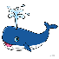  VLet's Learn the Ocean Zones!  Create a poster displaying the zones of the ocean. Draw and label a creature from each layer.  Challenge – Write a dialogue between two ocean creatures – the theme of the discussion could be environmental issues or social distancing rules or your own idea! | Have a go at improving your Welsh Skills!  Learn Welsh.net  Select Start –  from the category list,  choose Family  Try out the Family activities and games.  Challenge somebody in your house to do the test activity with you! Who will get the highest score?  Pob lwc! | Can you find the next number in a sequence?  Learn about it here!  https://www.bbc.co.uk/bitesize/topics/z69k7ty/articles/zyd4rdm  Try this game to practise your skills – there are lots of levels to challenge you! (scroll down to find the game)  https://mathsframe.co.uk/en/resources/resource/42/sequences | This week we are learning about following directions using a compass.  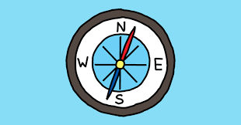  https://www.youtube.com/watch?v=Te0Td0QVoj0  Try this game to practise following directions: North, South, East and West. https://www.mathsisfun.com/games/direction-nsew-.html
Maths and Numeracy | Humanities | Science and Technology | Health and Well-being | Expressive Arts
How many litres of water does your kitchen sink hold? Use an old pop bottle or milk container to fill it. 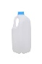Remember to check the capacity of the container first!  Can you convert the answer into millilitres?  Have a go at the questions in this video.  Maths KS2: Capacity and measure - BBC Teach | Ocean Explorer  .  KS2: Christopher Columbus - BBC Teach  www.bbc.co.uk › teach › class-clips-video › ks2-christo..  Write 5 quiz questions about Christopher Colombus for a friend to answer.  Post your quiz questions on humanities for your friends to try! Make sure you know the answers yourself! | Have you ever wondered how big, heavy, metal ships can float?  Have a look at this video to find out!  https://www.youtube.com/watch?v=CvWrkxzCiaY  Investigate how the shape of a boat affects it’s ‘buoyancy’.  Try making some foil boats in different shapes and see which one can carry the most pennies or stones.  (Or you could use recycled materials of different shapes and sizes)  https://www.youtube.com/watch?v=yzk1rkN9UAQ | Pretend you’re sailing the seven seas and learn a pirate dance!  https://www.youtube.com/watch?v=oe_HDfdmnaM  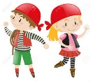  Then you can unwind with some ‘sea life’ inspired yoga!  https://www.youtube.com/watch?v=bIziRyUtj-c | Some amazing and beautiful creatures live in our oceans!  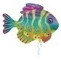  Paint or draw a colourful sea creature.  Include patterns and as much detail as you can.  Watch this video to give you some inspiration!  https://www.youtube.com/watch?v=WQlISC-N5Xw&list=RDCMUCRpNVpZoW56rOsV-6wFK3lg&index=1
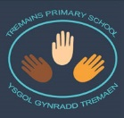
Home-School Activities - Summer Term 1

