Year 2  Date – Monday 29th - Friday July 17th (3 weeks) |  | Here are your tasks for the next two weeks. It’s up to you what order you do them in. Enjoy and stay safe!
Language, Literacy and Communication | Language, Literacy and Communication | Language, Literacy and Communication | Maths and Numeracy | Maths and Numeracy
Find out about the Rainforest. https://www.youtube.com/watch?v=3vijLre760w  Use this clip to get you started!  Check out assignments on the general channel to find out what to do.  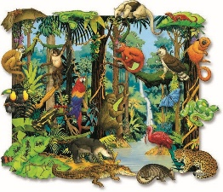 | Rainforest explorer!  Watch this clip https://www.youtube.com/watch?v=L7yFDikwERQ  Now imagine you are exploring the rainforest. Can you make your own mini wildlife film clip? You could use your garden, your house, anywhere that you visit on a walk as your setting. You could also use any toy animals that you have in your house. Remember as you spot different creatures make sure you tell the audience the name of the creature and a fact about it. | Write down the names of ten different rainforest creatures. Can you order them alphabetically? Can you think of another way to sort or order your items?  Extra Challenge! How many of the creature’s names can you spell without looking? | Can you remember this song about comparing numbers??  https://www.youtube.com/watch?v=xGvrG6049wE  Choose six different rainforest creatures and find out how much they weigh. Use the < > symbols to compare the weight of the different animals. You could also compare their heights too! | As you will find out it rains a lot in the rainforest! Can you make your own rain gauge? Use this link to help you.  https://www.science-sparks.com/wp-content/uploads/2015/04/Rain-Gauge.compressed.pdf  We hope to have lots of lovely sunny days but when it rains can you use your gauge to measure the rainfall?
Maths and Numeracy | Humanities | Science and Technology | Health and Well-being | Expressive Arts
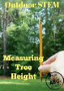  Can you measure the height of some trees in your garden or when you go on your daily walks? Use the sheet to help you – it is saved in the files section for you. Can you predict how tall they are? | Find out about the different layers of the rainforest.  https://www.youtube.com/watch?v=UIbplCn8-zs.  Can you draw and label a diagram of the different layers. Extra Challenge can you name one creature that lives in each layer? | Imagine you are going to the rainforest, you need a waterproof container to keep your belongings safe and dry. Create your own experiment to find out which materials are the most waterproof. Can you make a waterproof container? Have a look in your recycling – what could you reuse? | Take part in a wild workout with Andy… https://www.bbc.co.uk/programmes/p06tmrxr  Can you take part in some of the other workouts that Andy has done? | 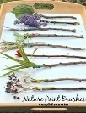  Create your own nature paint brush and paint a picture of the rainforest, you could use paints or you could make your own from mud, grass and other natural resources.
Home-School Activities - Summer Term 2

