Year 2  Date – Monday 1st^{th} Friday June 12th (2 weeks) |  | Here are your tasks for the next two weeks. It’s up to you what order you do them in. Enjoy and stay safe!
Language, Literacy and Communication | Language, Literacy and Communication | Language, Literacy and Communication | Maths and Numeracy | Maths and Numeracy
Over the next two weeks listen to the story of James and the Giant and the Giant Peach.  https://www.youtube.com/watch?v=gFoYBO5ZFwo  When you have finished the book have a go at this quiz!  https://www.roalddahlfans.com/fun-stuff/trivia-quizzes/james-and-the-giant-peach-quiz/ | Learn how to use question marks.  https://www.bbc.co.uk/bitesize/topics/z8x6cj6/articles/zcm3qhv  Now imagine you are going to interview your favourite Roald Dahl character and write a list of questions you would ask. Don’t forget to use question marks! | Use this ink to learn about how to use commas in a list. https://www.bbc.co.uk/bitesize/articles/zjs8wty  Now play this game to work on your punctuation skills. https://www.bbc.co.uk/bitesize/articles/zmnxt39 | Learn all about fact families  https://www.bbc.co.uk/bitesize/articles/zjn3gwx  Have a go at this activity to test your skills https://www.topmarks.co.uk/number-facts/number-fact-families | Did you Know that Roald Dahl kept a map in his office and every time a letter arrived from a new country, he would mark it with a pin! Watch this clip to learn about maps.  https://www.youtube.com/watch?v=DSnVCV4uGGQ  Now have a go at drawing a map of your house, garden or street.
Maths and Numeracy | Humanities | Science and Technology | Health and Well-being | Expressive Arts
Roald Dahl Problem Solving!  Use this link and scroll down to find Dahl’s Dinner Problem.  http://www.mathematicshed.com/maths-topic-shed.html  To work out who should sit where you could draw the table, write name cards or draw the characters. Good Luck!  Extra Challenge!  Have a go at the other Roald Dahl problems on this site. | Use this link to learn more about Roald Dahl’s life.  https://www.roalddahl.com/roald-dahl/timeline/1910s  Have a go at making timeline of your life or maybe of a grown up in your house. | Enormous Crocodile Seesaw  The Enormous Crocodile pretends to be a see saw in part of the story. Can you build a seesaw from recycled materials?  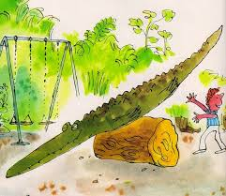 | Time for Yoga!  Enjoy this yoga session based on The Twits book.  https://www.youtube.com/watch?v=9vLpwN-_DGw&list=ULAtYrr1IFClM&index=410 | 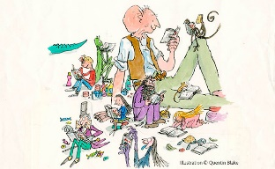  Roald Dahl created so many wonderful characters – but which one is your favourite???  Draw, paint or make a model of your favourite character. We can’t wait to see them!
Home-School Activities - Summer Term 1

