YEAR - 1  Date – Monday 29th June – Friday 17th July (3 weeks) |  | Here are your tasks for the next two weeks. It’s up to you what order you do them in. Enjoy and stay safe!
Language, Literacy and Communication | Language, Literacy and Communication | Maths and Numeracy | Maths and Numeracy | Health and Well-Being
Keep practising your spellings.  Learn to read and write these NEW ‘Tricky Words’.  Your list of spellings will be on a separate Seesaw post. | Write your own KINDNESS Acrostic poem. | Next time you are out and about look out for all the maths you see around. This could include numbers, shapes (2D & 3D), patterns, colours, etc. Take some photos or make a list of what you find.  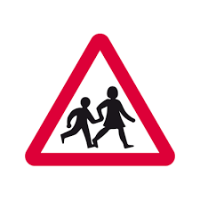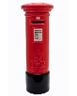  e.g. triangle, 2 children, 4 legs, circle, number 30, cylinder. | 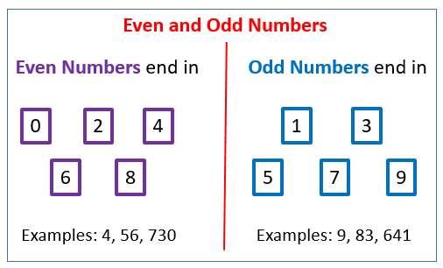  Explore and think about ‘Odd and Even’ numbers.  Use BBC Bitesize or Numberjacks to help. | Use a balloon to play these games: catch, tennis, see how long you can keep it off the ground.  Can you make up another game to play with a balloon?  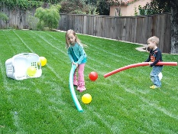
Health and Well-being | Humanities | Science and Technology/ Language, Literacy and Communication |  | Expressive Arts
YouTube: A Book about Kindness by Axel Scheffler  (You might want to mute this and enjoy reading it yourself)  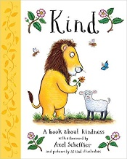  Look at this book with a grown up and think about all the kind things that you do. Draw a picture about it too and share this on Seesaw. | Find two photographs of yourself.  Then – when you started school in Nursery  Now – as you are in Year 1.  Talk about how you have changed since you were 3 years old: how you looked, clothes you wore, toys you played with, favourite TV programme, have you grown? games you play now, skills you have learnt, etc.  Think about how else you might change in the future. | In the Book about Kindness by Axel Scheffler there were pictures that showed how we can be kind to different animals.  Think about an animal that you could be kind to or help. This could be a pet in your house, an endangered animal, animals that live in sanctuaries, a zoo or safari or any animal that you are interested in.  Use Seesaw to show us the animal you have chosen and some information about how to help them.  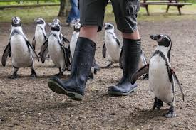 |  | Use a shoebox or other small box to create a 3D scene of an animal being cared for or protected.  