YEAR - 1  Date – Monday 1st June – Friday 12th June (2 weeks) |  | Here are your tasks for the next two weeks. It’s up to you what order you do them in. Enjoy and stay safe!
Language, Literacy and Communication | Language, Literacy and Communication | Maths and Numeracy | Maths and Numeracy | Science and Technology
Learn to read and write these ‘Tricky Words’.  Your list of spellings will be on a separate Seesaw post. | https://www.youtube.com/watch?v=46wCRq50Wwg  Listen to the story ‘The Lighthouse Keeper’s Lunch’ by Ronda and David Armitage.  Draw a picture of the lighthouse and add all the characters that are in the story. | Draw lighthouses like Mr Grinling’s.  Starting at the bottom, write a number sequence.  You could count in 2’s, 5’s, 10’s. How far can you count?  Challenge – don’t always start at 0, select a different starting number! | Data Handling  What are your family and friends’ favourite sandwich?  Collect the information in a tally  Cheese - ||||  Ham - ||  Can you draw a graph to display the results?  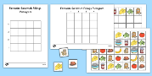 | In the story of the Lighthouse Keeper, Mr. Grinling has to go to the lighthouse ‘come rain or shine.’  Can you test which clothes would be the best for a rainy day?  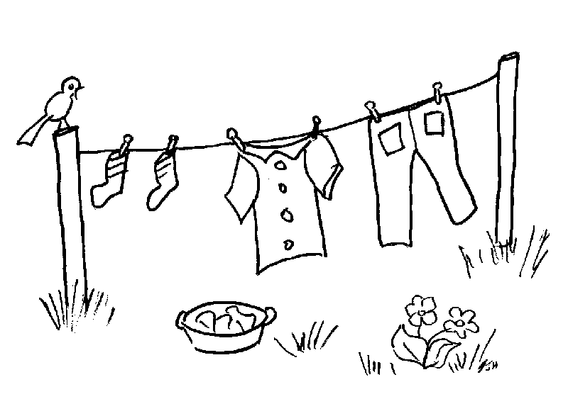  Can you guess (predict) which clothes will be waterproof?
Health and Well-being | Humanities | Science and Technology/ Language, Literacy and Communication |  | Expressive Arts
Listen to your favourite music.  Create a ‘playlist’ (on paper or media) of all the songs that make you feel happy or relaxed.  Listen to your playlist, chill out quietly or dance – it’s up to you! | Are there any lighthouses in Wales?  Perhaps you can find out!  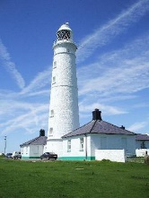 | Make your own sandwich!  Think about all the items you’ll need before you begin. Write a set of instructions explaining how to make your sandwich.  e.g.  1) Wash your hands.  2) Get two pieces of bread and the butter.  Don’t forget to write a list of ingredients/equipment too! |  | Build a model of a lighthouse using any materials available to you.  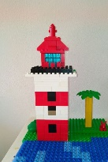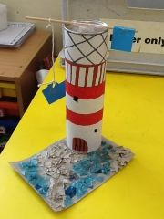  Be creative and design a colourful lighthouse you would like to live in!

