YEAR 5  Date –Monday 29th June to Friday 17th July (3 weeks) |  | Here are your tasks for the next two weeks. It’s up to you what order you do them in. Enjoy and stay safe!
Language, Literacy and Communication | Language, Literacy and Communication | Language, Literacy and Communication | Maths and Numeracy | Maths and Numeracy
Assignment  Remember our Missions? Here is your new one.  Look in Assignments to find out your mission about exploring Victorian gardens.  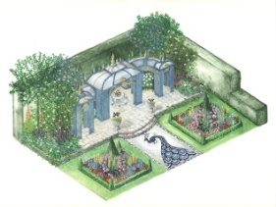 | Oracy  Voice 21: What’s the Word?  Use the cards in the LLC channel to play the Voice 21 game and define the word.  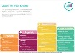  The cards are pinned to the top of Files in the LLC channel. | Listen to the story ‘The Knot’ by Helen Cousins being read by Mrs Morgan. Write a list of things that make you happy and calm.  Make your own Voice 21: What’s the Word? card game using the different emotions you can feel, some of which have been mentioned in the story.  Choose a story to read to a sibling/grandparent/parent. | Area and Perimeter  Watch the Live lessons football video and try to work out the area of the football pitch!  https://www.bbc.co.uk/bitesize/articles/zh9brj6  The sheet to help you is given below.  (You’ll need a calculator and pencil/pen.)  http://downloads.bbc.co.uk/learning/livelessons/supermoversshapesandspaces-activity1-areaandperimeter.pdf | Assignment  Look in Assignments and watch the BBC video. Complete the Area and Perimeter worksheet. All you need is there.  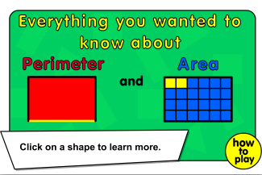
Maths and Numeracy | Science and Technology | Humanities | Health and Well-being | Expressive Arts
‘Wave your arms in the air’ with Percy Parker and learn the 8 x tables  https://www.youtube.com/watch?v=BMX8O0aGB0Q  Can you complete the booklet without looking at your 8xtables?  The booklet is pinned to the top of Files in the Maths & Numeracy channel | Assignment  Animal Engineers - Build a nest!  Many birds build nests.  Look at the Weaver bird’s nest in Assignments.  Now it’s your turn. Can you be an ‘Animal Engineer’? Design and build a nest to keep the bird’s eggs safe. Now research 3 other birds’ nests and present your findings in any way you wish.  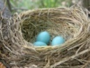 | Research at least 3 native plants from each continent. Display these in your own way on the world map provided.  (e.g. draw and label plant, print and stick picture )  Alternatively draw your own world map.  https://www.superteacherworksheets.com/maps/continents-oceans_WMZBN.pdf?up=1503417198  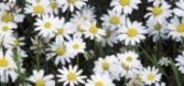 | Fill in this questionnaire about how you are feeling right now, then add up your score.  https://www.elsa-support.co.uk/wellbeing-questionnaire/ Look at the well-being calendar in the Health & Well-being Channel.  https://www.elsa-support.co.uk/wp-content/uploads/2020/05/Wellbeing-calendar-for-June.pdf  Create your own calendar for next 3 weeks, then repeat the questionnaire at the end of each week and see whether your score has improved. | Sketch a bird step by step.  Use this video to help you improve your sketching.  https://www.youtube.com/watch?v=UMwx4raERDs  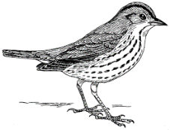  Challenge: Create a ‘Step by step’ drawing guide for a younger child to draw a bird.

