YEAR  Date – Monday 1st June to Friday 12th June (2 weeks) |  | Here are your tasks for the next two weeks. It’s up to you what order you do them in. Enjoy and stay safe!
Language, Literacy and Communication | Language, Literacy and Communication | Language, Literacy and Communication | Maths and Numeracy | Maths and Numeracy
Go to ‘Assignments’. Listen to the YouTube clip and write your own verses to the song, ‘What a Wonderful World’  The lyrics of the song are also in ‘Assignments’ | Word Play  Roald Dahl uses made up words and phrases in his books e.g. ‘phizz-whizzing’ and ‘troggle-humper’  Complete the activity below.  Now try and create your own made up words to the images you described in your wonderful world poem.  https://cdn.oxfordowl.co.uk/2016/06/21/15/44/21/480/Spoonerisms_Dahl_activity_sheet.pdf | Crystal Explorers  Collect the crystal shards unlocking the challenges and use your knowledge of grammar, punctuation and spelling to solve the puzzles  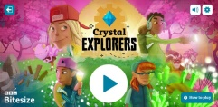  https://www.bbc.co.uk/bitesize/topics/zkbkf4j/articles/zbm8scw | Directions  Use the link below to practise directions using the 8 points of the compass.  https://www.bbc.co.uk/bitesize/topics/zvsfr82/articles/zdk46v4  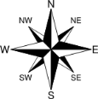  Now complete the activity in the Maths and Numeracy Channel.  You could also make your own for someone else to complete. | Go to ‘Assignments ‘. Use the grid or create your own to draw a map of your garden. Write a set of instructions using compass points to help direct a family member around it.  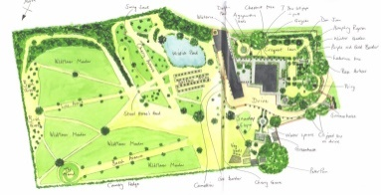
Maths and Numeracy | Science and Technology | Humanities | Health and Well-being | Expressive Arts
Interesting facts about the number  Number 7 is known as the number of perfection, security, safety and rest. There are 7 colours of the rainbow. There are 7 days in a week. Become a 7x table master and practise using the booklet in the M&N Channel https://www.youtube.com/watch?v=WdF_vFAxwas Can you create your own game to practise? | Create your own water cycle following the instructions below. You can use a plastic bottle if you don’t have a clear plastic bag.  https://www.mobileedproductions.com/blog/how-to-make-a-water-cycle-in-a-bag  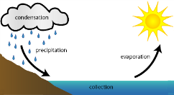 | RE  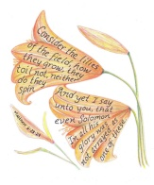  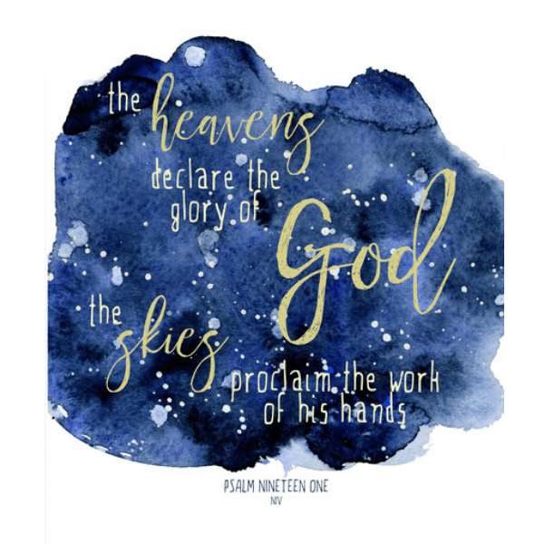  Read the bible verses about our wonderful world in the Humanities channel. Choose your favourite and create your own artwork to depict this particular verse. Look at the images in the Humanities Channel to inspire you. | Follow the work out instructions in the Health and Well-being Channel (also on Twitter).  ‘Dead lifts and Mountain Climbers!’  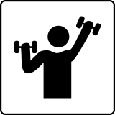 | 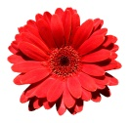  Capture an image from your garden or on your daily walks. You could use your phone to take a photo or use a variety of materials to draw a picture e.g. chalks, paints, pencil.  Check the details in ‘Assignments’.  Be creative!

