YEAR 4  Date – Monday 29th June to Friday 17th July (3 weeks) |  | Here are your tasks for the next two weeks. It’s up to you what order you do them in. Enjoy and stay safe!
Language, Literacy and Communication | Language, Literacy and Communication | Language, Literacy and Communication | Maths and Numeracy | Maths and Numeracy
ASSIGNMENT 1  Comprehension Activity  ‘Lava Lake’ | Using the Ocean Cards, discuss  - What you see  - Why this is happening  - How it makes you feel  - What you could do about it  Remember take turns to speak and use your cognitive skills to give reasons and opinions  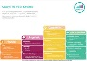  The cards are pinned to the top of files in the LLC channel | Use your research skills to find out about the Earth’s ‘Ring of Fire’.  Find out at least 5 facts – you could use them in your mission task.  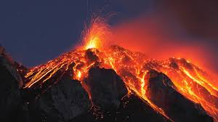 | ASSIGNMENT 2  Maths Activity Booklet | Capacity is the amount a container can hold e.g. a squash bottle can hold 1 litre of squash…  Now take part in ‘Who Wants to be a Millionaire’!  The Powerpoint is pinned to the top of files in the Maths channel
Maths and Numeracy | Humanities | Science and Technology | Health and Well-being | Humanities
Measuring Investigation  How many of your own feet fit your height? Use a template of your foot to work it out.  How many of each of your family members’ feet fit their own height?  Compare your results. What do you notice? Are there any patterns?  Record what you found out. We would love to see this on the Maths channel. | ASSIGNMENT  MISSION:  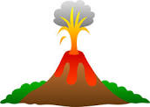  ‘Volcanoes -Sleeping Giants?’ | Make your own volcano!  Follow the instructions carefully and remember, it could get messy!  Have fun! Yes, we definitely want to see your photos and videos! Upload them on the Science and Technology Channel -or they could be part of your mission!  Instructions are pinned to the top of files in the Science channel | Read these words:  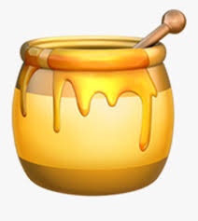  ‘Kind words are like honey: sweet to the soul and healthy for the body’  What do you think this means?  See if you can find out where these words come from!  If you like them and think they may help you as a reminder, make yourself a poster with them and decorate it as you wish! | Exploring the life of Jesus  Read about Jesus and the Paralysed Man and complete the talk activties with someone in your house.  You can read about Jesus and the blind man too.  How are the stories similar?  What do they tell you about Jesus?  Powerpoints are pinned to the top of files in the Humanities channel

