Mrs Mayberry and Mrs Kingston N-Yr 2  Date – Monday 1st June to Friday 12th June (2 weeks) |  | Here are your tasks for the next two weeks. It’s up to you what order you do them in. Enjoy and stay safe!
Language, Literacy and Communication | Language, Literacy and Communication | Maths and Numeracy | Maths and Numeracy | Science and Technology
Follow the recipe on Seesaw to make the no cook play dough. You will need this for another activity. | 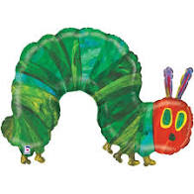  Use the link on Seesaw to listen to the story ‘The Very Hungry Caterpillar’ by Eric Carle. Draw or write about your favourite part of the story. | Use the play dough that you made to create numbers.  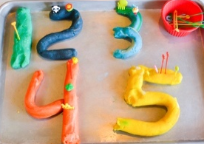 | Complete the caterpillar patterns (see attached sheet). You can do this using counters, buttons, pieces of coloured paper or you can colour in the dots on the sheet.  Can you make your own caterpillar patterns?
Science and Technology | Humanities | Health and Well-being | Health and Well-being | Expressive Arts
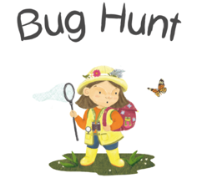  Go on a bug hunt! Take a photo of the bugs and upload then to Seesaw. Can you say or write their names? |  | Join in with the Jack Hartman videos, counting in:  2’s, 5’s and 10’s.  Click on each number to start.  10  5  2 | Click on the picture to watch the video.  Join in with the words and actions in the ‘Bug ‘n’ Roll’ song.  Can you make up your own bug dance? | Create a butterfly by painting one half of a piece of paper and folding it in half. Take a photo for Seesaw
