YEAR - NURSERY  Date – Monday 11th May to Friday 22nd May (2 weeks) |  | Here are your tasks for the next two weeks. It’s up to you what order you do them in. Enjoy and stay safe!
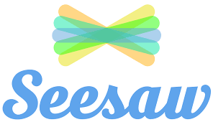  Language, Literacy and Communication | Language, Literacy and Communication | Maths and Numeracy | Maths and Numeracy | Science and Technology
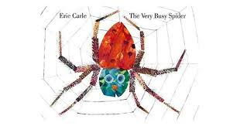  https://www.youtube.com/watch?v=nEPYKmIt4dU Use this link to listen to the story ‘The Very Busy Spider’ by Eric Carle. Join in with repetitive language and make the animal sounds throughout.  Now create a picture of the spider and have a go at writing ‘spider.’ | 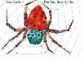  S is for Spider!  Can you find more objects beginning with ‘s’? Try drawing them and write ‘s’ next to them; if you want a challenge try sounding out and writing the word for each object.  For example:-  S is for spoon. | 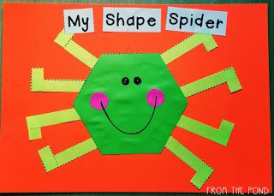  Make a shape spider of your own! | 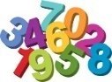  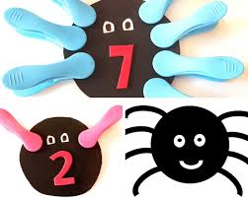  Make some peg spiders, like the ones below- give them different numbers of legs using pegs! | Watch Come Outside Spiders!  https://www.youtube.com/watch?v=UQ2RzDl0vvM  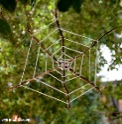  Watch how a spider makes its web!  Now, pretend to be a spider and use thread to make your own web!
Science and Technology | Humanities | Health and Well-being | Health and Well-being | Expressive Arts
https://www.youtube.com/watch?v=WUx2qqPUyOI Watch this clip to find out some amazing facts about spiders.  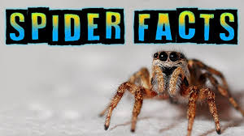  Can you share some spider facts with a family member? | 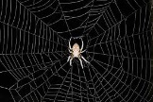  Where do spiders live? Go on a spider adventure! Can you find spider webs inside and outside your house? Are they up high or down low? How many altogether?  Now, create your very own spider web picture! | 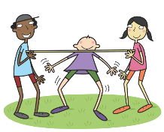  Spiders have bendy legs! Can you play a game of Limbo with your family? Who can get closest to the ground like a spider? | 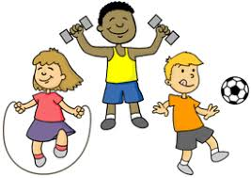  https://www.youtube.com/watch?v=4UyPe7S0cSg Have a go at Cosmic Counting with ‘Peace Out Relaxation for Kids.’ | 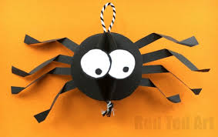  https://www.youtube.com/watch?v=MHLJEi1JbxE Use this link to join in with the ‘Being a Spider’ song.  Can you make your very own spider with 8 moving legs?

If your child knows all of their letter sounds, they can start to learn stage 1 key words. Starting with ‘Biff’, work your way down the first column, then onto the next column and the next. This is the correct order for the children to learn their key words, which corresponds with the Oxford Reading Tree scheme. Use Oxford owl online for the children to match their key words to the books they see on screen.

to | In | Biff
went | got | Chip
was | go | Kipper
said | up | Floppy
she | you | and
day | I | Dad
can | is | Mum
look | Is | a
my | no | big
are | it | at
away | It | the
all | did | yes
come | me | get
for | see | this
cat | we | on
dog | who | in

