YEAR 6  Date – Monday 11th to Friday 22nd May (2 weeks) |  | Here are your tasks for the next two weeks. It’s up to you what order you do them in. Enjoy and stay safe!
Language, Literacy and Communication | Language, Literacy and Communication | Language, Literacy and Communication | Maths and Numeracy | Maths and Numeracy
The Spider and the Fly (1)  Originally a poem, The Spider and the Fly' by Mary Howitt describes the entrapment of a silly fly who gives into her own vanity and loses her life to a cunning spider.  Watch the animation  https://www.youtube.com/watch?v=XOjXlIqoCyo  Complete the book talk activities below.  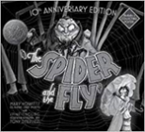 | The Spider and the Fly (2)  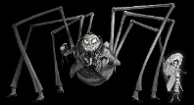  Victorian Vocabulary  You might be amused by knowing the names that wealthy middle class Victorians gave to various rooms in their houses - most of which we either don’t use now, or have changed their use.  Word hunt – find the Victorian words in the poem and write a definition – what room, if any, does this compare with in your home? | Spelling and Grammar  https://www.topmarks.co.uk/english-games/7-11-years/spelling-and-grammar  Creepy verbs and adverbs  What is a verb? What is an adverb? – the link will remind you if you have forgotten!  Play the game - Select effective verbs and adverbs to transform a boring horror story into a best seller entitled :  “The Sea Cave” | 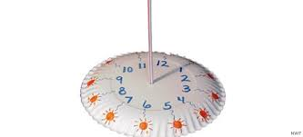  - Paper Plate Sundial  Look in our Maths and Numeracy Channel for instructions.  If you don’t have a paper plate, use whatever you can!  When the sun is shining use your sundial and check how accurately it works by using it to tell the time! Were you right? | Telling the Time  What’s the time?  Use the link below to help you tell the time in analogue, digital and 24hr formats!  https://www.topmarks.co.uk/Search.aspx?q=telling+time  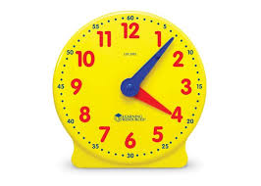
Maths and Numeracy | Health and Well-being | Health and Well-being | Science and Technology | Science and Technology
SPIDERS HAVE 8 LEGS!  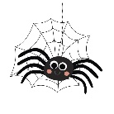  Mr Hillman’s favourite!  Brush up on your 8 times table.  https://youtu.be/z_BJjR9rdwA  Choose how to practise your 8 times table…You could simply write it out and recite it and/or look in the Maths and Numeracy Channel and choose an activity that you would like to do. | Have a look in the Health and Well-being Channel.  Choose a recipe and have a go at cooking it.  Then the best part….eating it! | 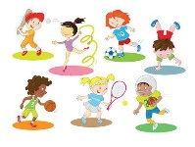  Spider Fly Circuit  Look in the Health and Well-Being Channel and challenge yourself to complete the ‘Spider Fly’ Circuit.  Choose how many times you want to complete each exercise – 8 seconds of each? 8 minutes total time? 8 repetitions each? You decide! | www.barefootcomputing.org/homelearning  Click on the link for enjoyable activities from the computing curriculum.  Check out the ‘Learning together activities’ and have a go at the ‘Hand Jive Sequence’ or ‘Dance Moves’ tasks | Classifying Animals  Spiders are arachnids and flies are insects – both are invertebrates.  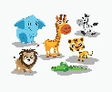  But what can you find out about vertebrates?  Watch:  https://www.youtube.com/watch?v=mRidGna-V4E  Look in the Science and Technology Channel for what to do next!

Supporting material
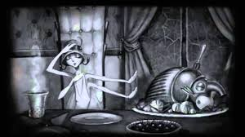
Activity 1 The Spider and The Fly
Book Talk
- The book is in black and white. Why do you think the writer made that decision?
- Look closely at the pictures
- What is the morale of the story?
- List :
5 things in the spider’s kitchen,
5 things in the fly’s handbag

- Page 17 – 2min 21 – Can you draw what the spider did?
- Write a 50 word summary retelling the poem.

Daily Reading continuation
How many of these titles can you read?
http://trentceprimaryschool.co.uk/wp-content/uploads/2016/11/100-Books-To-Try-And-Read-Before-You-Leave-Year-6.pdf
20 minutes a day recommended.

Science and Technology Channel

Make notes from the YouTube clip and/or research each type of VERTEBRATE.
Make a factfile for each vertebrate category (mammal, fish etc).
Explain the characteristics and give examples. Insert suitable pictures/diagrams too!
Present your work using the Word Document in the Science and Technology folder.

Maths and Numeracy Channel
Upload the 3 documents: 8 times table fortune teller, 8 times table game, 8 times table booklet.

