Year 3  Date – Monday 11th to Friday 22nd (2 weeks) |  | Here are your tasks for the next two weeks. It’s up to you what order you do them in. Enjoy and stay safe!
Language, Literacy and Communication | Language, Literacy and Communication | Language, Literacy and Communication | Maths and Numeracy | Maths and Numeracy
Seven Continents of the world - Seven continents ... - YouTube  List three countries in each continent and their capital cities.  What other facts can you find out?  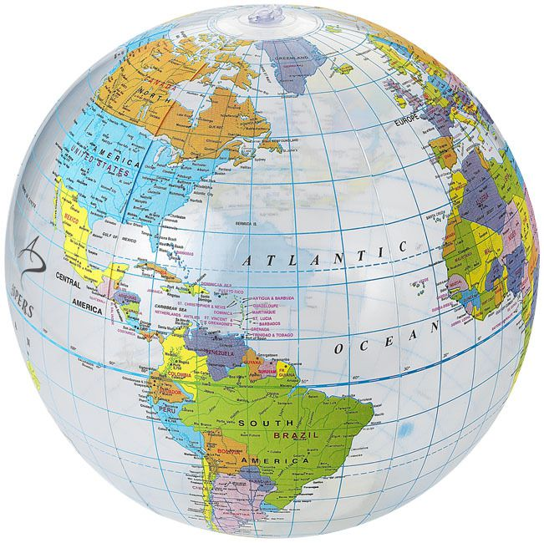 | What continent is Italy in? Can you research three famous tourist attractions in Rome.  Imagine you are in Italy, write a postcard home about the tourist places you have found out about.  Record your work in the Literacy file.  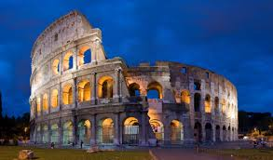 | 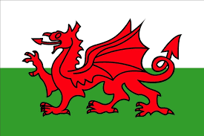  Learn Welsh.net  www.learn-welsh.net  Select – Activity, full tutorial  Daily Routines & Hobbies  Challenge – Try out the games too! | How well do you know your number bonds – to 20? 100? 1000?  Get on board the Mental Maths train to find out! Select the addition ( + ) carriage and you’ll find the ‘Bonds’ games on the right hand side of the menu.  https://www.topmarks.co.uk/maths-games/mental-maths-train | In school you have been learning about fractions. Practise what you know and challenge yourself further with these activities.  https://phet.colorado.edu/sims/html/build-a-fraction/latest/build-a-fraction_en.html
Maths and Numeracy | Humanities | Science and Technology | Health and Well-being | Expressive Arts
Draw or paint a pizza.  https://www.youtube.com/watch?v=fhxFsrt3T2o  Can you cut it into halves, quarters, or even eighths?  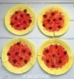  If the whole pizza costs £2.40, how much would a half, a quarter or an eighth cost?  Challenge – try changing the price of the pizza and work out the prices per slice. | Science KS2: Discovering the work of Leonardo da Vinci - BBC  Tell the people in your house 5 interesting facts about Leonardo da Vinci’s inventions  Can you invent a machine to make your life easier?  Draw your ideas, add notes to explain how it would work.  Upload your ideas into the Humanities file.  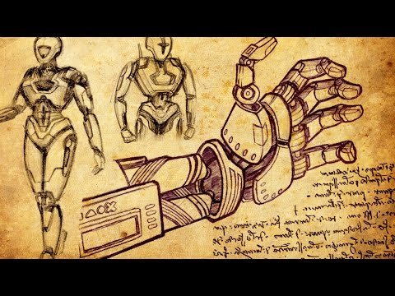 | Did you know that Leonardo da Vinci’s inventions include the earliest parachute?  Watch the clip to see  how parachutes work.  https://www.youtube.com/watch?v=Ab_g5sLoXoY  Try making and testing your own parachute!  https://www.wikihow.com/Make-a-Toy-Parachute | Family fun - have an Italian themed night!  You could include Italian food, like pizza or pasta.  Learn to Dance the ‘Tarantella’ – a traditional Italian dance.  (If you don’t have a tambourine, just clap your hands!)  https://www.youtube.com/watch?v=9eef7ENpmO8 | Luciano Pavarotti is a famous Italian opera singer.  Listen to :-  Puccini: Turandot - Nessun Dorma! - YouTube  Copy a flag from one of the countries you have researched or design your own flag!
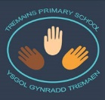
Home-School Activities - Summer Term 1

