YEAR 2  Date – Monday 11th to Friday 22th May (2 weeks) |  | Here are your tasks for the next two weeks. It’s up to you what order you do them in. Enjoy and stay safe!
Language, Literacy and Communication | Language, Literacy and Communication | Language, Literacy and Communication | Maths and Numeracy | Maths and Numeracy
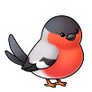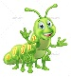  Research different birds and bugs. Use these clips to get you started!  Why insects are so amazing  https://www.bbc.co.uk/newsround/49051971  Birds you may see on your daily walk:  https://www.youtube.com/watch?v=amYUDQDtm9E | Make your own list of interesting facts about birds or bugs.  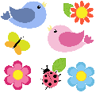 | Are you a bookworm?  Explore some new books through Oxford Owl or maybe you have some at home. You may even find a book about birds or bugs! | Use this link to learn to identify the different birds that you see in your garden on a walk  https://www.rspb.org.uk/birds-and-wildlife/wildlife-guides/identify-a-bird  Use J2Data to make a graph of the birds you spot. | Make your own mini beast top trumps cards Here are some links to help you with ideas. https://www.tes.com/teaching-resource/minibeast-trump-cards-6123525  https://www.twinkl.co.uk/resource/t-n-825-minibeast-highest-value-top-trump-cards  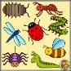  Share the cards with a member of your family and compare the mini beasts! Can you add the numbers? Find the difference?
Maths and Numeracy | Humanities | Humanities | Health and Well-being | Expressive Arts
Shapes appear in nature e.g. tree trunks are cylinder like.  Watch this bitesize clip and find out the properties of 3D shapes.https://www.bbc.co.uk/bitesize/topics/zjv39j6/articles/zgqpk2p. Can you take the quiz to test what you have learnt? Now go on a hunt for 3d shapes in the environment! | Draw a diagram or make model of your favourite bird or bug. Can you label it?  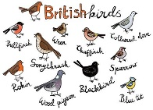  Can you share your work with us?  We would love to see a photograph of what you have done! | 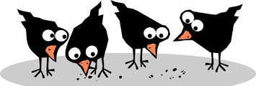  Birds' beaks have adapted to be the best shape to pick up the food they eat. Try using chopsticks, a spoon, a clothes peg or tweezers as a beak to pick up small items in your house. Which beak is best for each thing? | Think about how birds and bugs move Create your own mini fitness circuit. You could flap like a bird or crawl like a spider! Complete your circuit every day! Encourage everyone in your house to have a go!  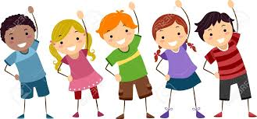  Who will be the fastest? | learn the song and create your own actions  https://www.youtube.com/watch?v=0fsKP-EtByA

