YEAR - 1  Date – Monday 11th to Friday 22nd May (2 weeks) |  | Here are your tasks for the next two weeks. It’s up to you what order you do them in. Enjoy and stay safe!
Language, Literacy and Communication | Language, Literacy and Communication | Maths and Numeracy | Maths and Numeracy | Science and Technology
Use YouTube and listen to or read these 3 books:  - The Enormous Crocodile (Roald Dahl),  - Winnie the Witch (Valerie Thomas)  - The Very Hungry Caterpillar (Eric Carle). Now try the quiz questions on the next page! | 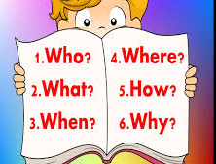  Read one of your favourite books. Now write your very own quiz or think of questions you can ask and test your family and teachers!  It can be a story (fiction) or a fact book (non-fiction). | 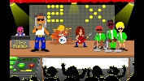  Percy Parker – Learn your 10, 5 and 2 times tables  x10  https://www.youtube.com/watch?v=sr0mnSgjJDU  x5  https://www.youtube.com/watch?v=A8cCyQTkRgI  x2  https://www.youtube.com/watch?v=BMX8O0aGB0Q  They’ll be on Seesaw too! | 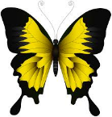  Symmetry – Have you noticed that a butterfly’s wings are symmetrical?  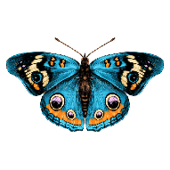  Using any media, design your own butterfly wings. Make sure they are symmetrical.  Challenge – Make some you can wear and take a photo! | 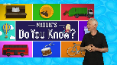  https://www.bbc.co.uk/iplayer/episode/m0004xrx/sign/maddies-do-you-know-series-3-7-butterfly-and-wallpaper  Watch this episode on BBC iPlayer or search YouTube for Maddie’s Do You Know Butterfly and wallpaper
Science and Technology | Humanities | Health and Well-being | Humanities | Expressive Arts
Create a fact file about a minibeast, e.g. bee, ladybird, caterpillar.  You could include a labelled picture, a description, some interesting or unusual facts and even a little quiz at the end! | Now that you have drawn a picture of your house, choose your favourite room and paint/draw a picture of it or make a model of it using recyclable materials/Lego or any other construction kit you might have.  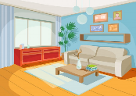  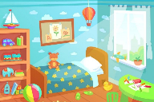 | Draw all the foods that the Hungry Caterpillar ate. 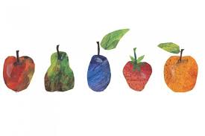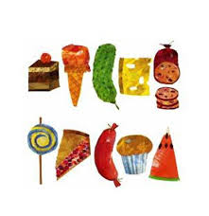  Write out 2 labels: ‘Healthy’ and ‘Not so Healthy.’ Can you sort the foods into the two sets?  Can you add any other foods to the ‘Healthy’ set? | Recycling  In Bridgend we use different bags when we put our rubbish out.  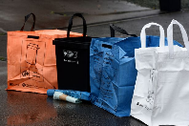  Over the next 2 weeks, help a grown up to sort the materials into your recycling bags and put them out for the recycling lorry when it comes.  You could even write a thank you message for the key workers collecting the recycling and rubbish. | Watch the video above first!  Design your own wallpaper or repeating pattern. Think creatively –  - Draw and colour  - Paint  - Print  - Use toys  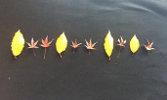  - Use natural materials from the garden  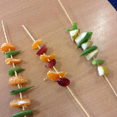  - Food kebabs

The Enormous Crocodile by Roald Dahl
- What did the Enormous Crocodile do to Trunky the elephant?
- What sort of tree did the Enormous Crocodile pretend to be?
- What happened to him at the end of the story?
Winnie the Witch by Valerie Thomas
- Can you name all the colours of Wilbur the cat when Winnie used her magic? Can you name them in Welsh too?
- What happened to Winnie when she put Wilbur outside on the grass?
The Very Hungry Caterpillar
- How many strawberries did the caterpillar eat?
- Can you name all the foods that the Hungry Caterpillar ate?

Listen to each story on different days.

