Date – Monday 11th to Friday 22nd May (2 weeks) | Mr Maybery & Mrs Kingston N – Y2 |  | Here are your tasks for the next two weeks. It’s up to you what order you do them in. Enjoy and stay safe!
Language, Literacy and Communication |  | Language, Literacy and Communication | Maths and Numeracy | Maths and Numeracy
https://www.youtube.com/watch?v=nEPYKmIt4dU  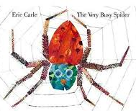  Use this link to listen to the story ‘The Very Busy Spider’ by Eric Carle. Join in with repetitive language and make the animal sounds throughout. |  | Use seesaw to send me a message to let me know how you are getting on. This could be a video, voice recording or written. | 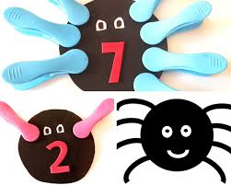  Make some peg spiders, like the ones below- give them different numbers of legs using pegs! | Make a shape spider of your own!
Science and Technology |  |  | Health and Well-being | Health and Well-being | Expressive Arts
Watch the video about spiders. Can you draw a picture of a spider, or draw and label a picture of a spider. Perhaps you could write a fact about spiders.  https://www.youtube.com/watch?v=WUx2qqPUyOI |  |  | https://www.youtube.com/watch?v=0TgLtF3PMOc  Dance along and count to 100 with one of our class’ favourite songs! | Log on to Seesaw and find the activity ‘Create A Drawing: Dot Day’ Use Seesaw to create your own Dot Day drawing. | 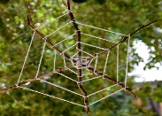  Can you weave a web for a spider? You could use some sticks collected from your walk and some wool/ribbon/string or any other material you may have in the house. Upload a photo/video of your web to Seesaw.
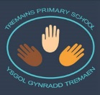
Homeschool Activites - Summer Term 1

