YEAR - NURSERY  Date – Monday 27th to Friday 8th May (2 weeks) |  | Here are your tasks for the next two weeks. It’s up to you what order you do them in. Enjoy and stay safe!
Language, Literacy and Communication | Language, Literacy and Communication | Maths and Numeracy | Maths and Numeracy | Science and Technology
Make a set of weather cards that can be used to practise your Welsh: draw a weather symbol and overwrite/ copy each word onto the card. You can teach your family how to play the ‘Sblat’ game.  Sunny- heulog  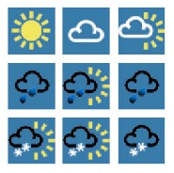  Cloudy- gymylog  Raining- bwrw glaw  Windy- wyntog  Cold- oer  Hot- boeth  Snowing- bwrw eira | Make a rainbow card/ postcard for a neighbour or family member and post it.  Have a go at sounding out words, your grown-ups can help you to overwrite or copy each word.  Use: https://www.youtube.com/watch?v=U2HYM9VXz9k  to continue to practise Jolly Phonics sounds- see attached sound order. | Fun with shadows-use chalk to draw around shadows or use a piece of paper and pencils. Draw around your family’s shadows and measure each one. You can use hand spans, steps, string or a tape measure. Find out who has the tallest/ shortest shadows? Are the shadows the same size as each person?  You could do this with other objects too- toys, plants etc | Practise counting as far as you can, as well as backwards from 20-0. Sing number rhymes to help.  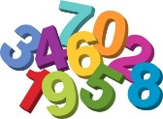  Make a set of number cards up to 10 initially (those children who can recognise no’s to 10 can make cards to 20.) Match number to quantity- this can be done with any objects available inside or outside.eg. stones, leaves, twigs, pencils, toys etc. You could draw around items and write the number to match the quantity. | 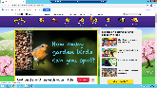  https://www.bbc.co.uk/cbeebies/joinin/garden-bird-spotting Stick 2 empty toilet rolls together and add string each side to create a pair of binoculars. Go bird watching from your window or garden- can you name each bird? Find out the names of any unknown birds. Record your findings- your grown-ups could help you to:  make a tally chart, draw each bird and label their name, write a list, take photos- this is up to you!
Science and Technology | Humanities | Health and Well-being | Health and Well-being | Expressive Arts
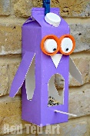  Junk modelling- make an item for the birds- this could be a birdhouse, a birdfeeder, a bird bath, a bird nest etc Think about which materials would best suit the job- talk about this with your grown-ups. Do you know what each material is? | 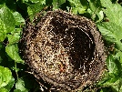  Talk to your grown-up about where bird’s nests are (if you can, try to find one when you are out walking)- why do you think they build their nests in trees? Can you name the parts of the trees? What do bird’s use to build their nests with? Why do birds build nests?  Challenge- can you build a bird nest? This could be a bird sized nest or a nest big enough to fit you in! | 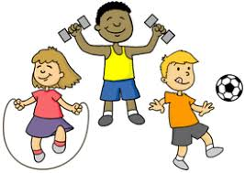  Make up an obstacle course for you and your family to use. Who can get around it the fastest? Count how many seconds it takes each person to complete it. | Use the obstacle course that you made previously and move around it like an animal of your choice! (You could jump like a kangaroo, crawl like a ladybug etc) | 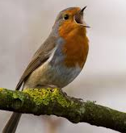  Make your very own set of wings to match your favourite bird. Think about their shape and colour. What can you use to decorate them? Once you have made your wings, pretend to be your favourite bird and sing to your heart’s content!

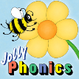
Jolly Phonics correct order:

- s, a, t, i, p, n | - c k, e, h, r, m, d
- g, o, u, l, f, b | - ai, j, oa, ie, ee, or
- z, w, ng, v, oo, OO | - y, x, ch, sh, th, th
- qu, ou, oi, ue, er, ar

