YEAR 6  Date – Monday 27th to Friday 8th May (2 weeks) |  |   Here are your tasks for the next two weeks. It’s up to you what order you do them in. Enjoy and stay safe!
Language, Literacy and Communication | Language, Literacy and Communication | Language, Literacy and Communication | Maths and Numeracy | Maths and Numeracy
 Persuasive speech  April 22nd 2020 marked the 50th anniversary of Earth Day.  Research what Earth Day is and write a persuasive argument to an adult persuading them how making some simple changes to their lifestyle could help save the earth for future generations.  Pizza success criteria included | Daily Reading    How many of these titles can you read over the coming weeks?  http://trentceprimaryschool.co.uk/wp-content/uploads/2016/11/100-Books-To-Try-And-Read-Before-You-Leave-Year-6.pdf  20 minutes a day recommended. |   https://www.mylockdowndiary.com/  Print off (or design your own pages using the ideas from the link) and begin completing your own ‘Lockdown Diary’.  Try and complete one page a day.    You will be able to keep this as a record of this strange time! | Mental Maths Challenge    Choose your level, choose your topic, choose your thinking time!  https://www.topmarks.co.uk/maths-games/daily10 | Snowdon Stair Climb Challenge  Mount Snowdon, Wales    1,085 m (3,560 ft)  Total steps - 7,120  Total flights of stairs - 475  Please see the supporting document.
Maths and Numeracy | Science and Technology | Humanities | Health and Well-being | Expressive Arts
  Times table daily practise!  Choose a times table that you need to learn/improve on.  Write out the times table.  e.g. 1 x 2 = 2  2 x 2 = 4 etc  Recite it. Quick fire answers in mixed order.  Choose a song to sing and dance along to!  https://www.bbc.co.uk/teach/supermovers/times-table-collection/z4vv6v4 | Grow a Rainbow – Support the NHS    Follow these instructions:  https://www.thebestideasforkids.com/grow-a-rainbow-experiment/  How are real rainbows made? Find out and explain to a member of your family. | Our topic this term is  ‘Mother Nature At Her Best’  Watch:  https://www.youtube.com/watch?v=WmVLcj-XKnM  What is the message in this film?  Using emotive language, write your own Mother Nature speech/message. You can use phrases from the clip and add some of your own. |   Snowdon Stair Climb Challenge  Increase the number of steps you take each day by virtually ‘climbing’ Snowdon   |   Look at images of ‘Mother Nature’ on Google.  What do you think she looks like?  Create a Mother Nature artwork. You can use whatever media you choose –  Sketch, paint, collage, outdoor nature creations etc.  Create your own image or try to copy an image you like from the Internet.

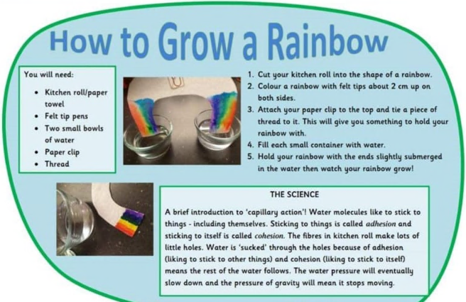
Snowdon Stair Climb Challenge
Working out your target
First you will need to have an idea of how many flights of stairs you can realistically climb in a week so that you can work out your own weekly goal and then challenge yourself.
Count and record how many steps you climb each day, for seven days. This is your ‘baseline week’. What’s the highest number of steps you climbed in any one day? This is your daily steps target. You should aim to complete this many steps every day.
It is hard to keep track of the total number of individual steps you should be taking a day, so instead record the number of flights you climbed. There are 15 steps in an average flight of stairs.
How to work out your target for the Stair Climb Challenge
What’s the highest number of steps you climbed on any one day in your baseline week? This is your daily steps target.
Divide your daily steps target by 15 (the average number of steps in a flight of stairs). This is your daily flight goal.
Multiply your daily flight goal by 7 (days in a week). This is your Weekly flight goal.

GRAB A PIZZA SUCCESS!  Persuasive writing |  |  | 
Toppings that must be included |  | Self  Assess | Grown up  Assess | TA
1 | My text has an interesting title.
2 | I have thought about the audience I am writing for and how I will persuade them.
3 | I have an introduction that grabs the reader’s attention and clearly explains my opinion about the topic.
4 | I have given strong reasons for my opinion and have explained these using interesting facts and details.
5 | I have a conclusion that restates my opinion, reminds the listener of my reasons and leaves them with something to think about.
6 | I have written in paragraphs and each contains one main idea or set of ideas.
7 | I have used linking words (connectives) to help the listener follow what is said.
8 | I have used strong persuasive language throughout.
9 | I have checked my work carefully with an adult and have corrected any spelling, grammar or punctuation mistakes.
Extra Sides
 | I have used different types of sentences for impact.
 | I have involved the listener with persuasive devices such as rhetorical questions.

