YEAR 5  Date – Monday 27th to Friday 8th May (2 weeks) |  | Here are your tasks for the next two weeks. It’s up to you what order you do them in. Enjoy and stay safe!
Language, Literacy and Communication | Language, Literacy and Communication | Language, Literacy and Communication | Maths and Numeracy | Maths and Numeracy
Research different adverts for holiday destinations. Watch some on YouTube and think about how they persuade people to visit that destination.  Pizza success criteria included | Create your own advert for a destination of your choice. Find out about the attractions in that area. You can present this any way you like as a poster, a script for a TV advert, a leaflet etc. | Imagine you are at the destination of your choice and write a diary entry about where you have visited. It could be somewhere you’ve been already or you can choose somewhere you’ve always wanted to go. Be creative! | 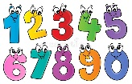  Write out a times table, practise it and then test yourself using J2blast on Hwb. | Rounding Numbers  https://www.bbc.co.uk/teach/supermovers/ks2-maths-rounding-numbers-with-laura-bubble/zhmrhbk  Listen to the song and then complete the animation and activity on rounding numbers.
Maths and Numeracy | Science and Technology | Humanities | Health and Well-being | Expressive Arts
Game - Guardians: Defenders of Mathematica  https://www.bbc.co.uk/bitesize/topics/zd2f7nb/articles/zn2y7nb  For you ‘Battleground’ choose ‘Place Value’ and ‘Addition and subtraction’  Don’t forget to have some paper and a pencil ready to work out your sums. | Grow a Rainbow – Support the NHS  Follow these instructions:  https://www.thebestideasforkids.com/grow-a-rainbow-experiment/  How are real rainbows made? Find out and explain to a member of your family. | RE - Creation  https://request.org.uk/restart/2020/03/26/bible-quest-creation/  Watch the video and create a story board of the events of each day. E.g.  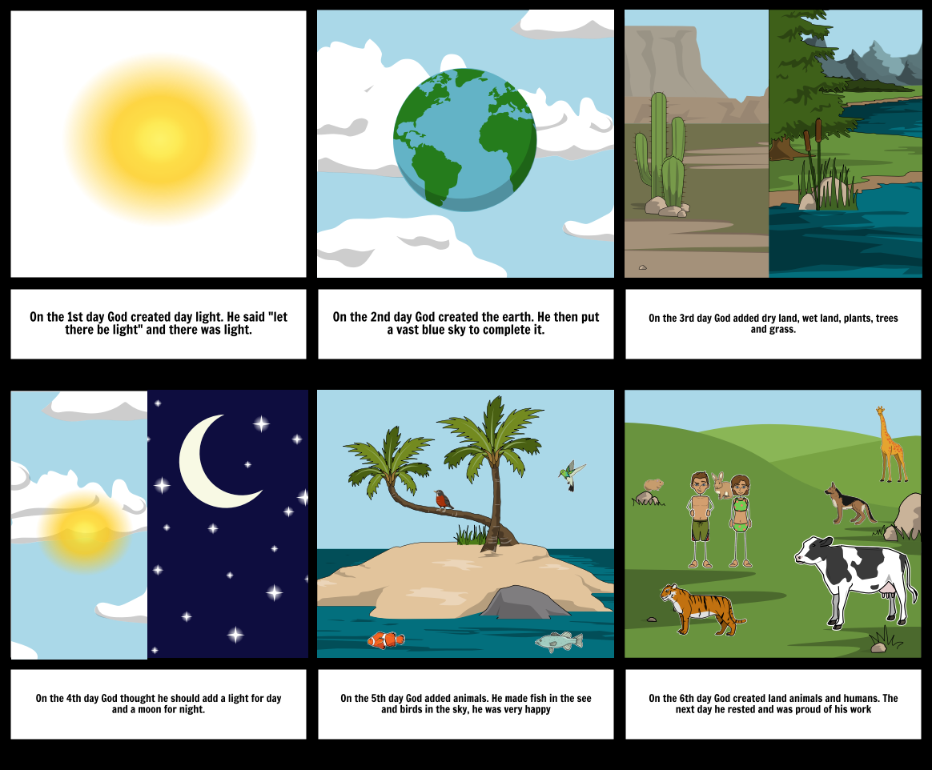 | Set yourself a challenge for the week. It could be to do a 100 skips a day, a 100 keepy uppies a day, to do the Joe Wicks videos every day or to tune into Oti Mabuse on YouTube every day to learn a dance. | Create a junk model out of your recycling. It needs to help you with a job around the house during lockdown, e.g. a robot, coffee maker, desk tidy etc. Decorate it then present it to a family member explaining what it does and how you made it.

GRAB A PIZZA SUCCESS!
Holiday Advert
Toppings that must be included |  | Self  Assess | Grown up  Assess | TA
1 | Includes an image of the destination
2 | I have used persuasive language
3 | I have used appealing adjectives to draw the readers in
4 | I have included interesting facts about the holiday destination
Extra Sides
 | I have asked rhetorical questions
 | I have included quotes from satisfied customers

