Year 3  Date – Monday 27th to Friday 8th May (2 weeks) |  | Here are your tasks for the next two weeks. It’s up to you what order you do them in. Enjoy and stay safe!
Language, Literacy and Communication | Language, Literacy and Communication | Language, Literacy and Communication | Maths and Numeracy | Maths and Numeracy
Draw and label a diagram  of a  flowering plant.  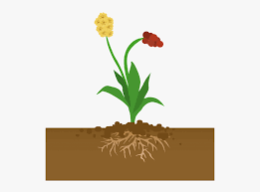 | Learn how to spell the days of the week and months of the year.  Challenge yourself to learn how to spell them in welsh too! | https://www.mylockdowndiary.com/  You can print this off or use the ideas to design your own pages! Try to complete at least one page each day.  It will be fun to share some memories when we’re all back together again! | Spend 15 minutes each day learning and practising your tables. You could try saying them out loud, writing them down or you could make your own poster.  Test yourself with ‘Hit the Button’  https://www.topmarks.co.uk/maths-games/hit-the-button | This is a great time to work on your mental maths skills. Have a go and remember to challenge yourself!  https://www.topmarks.co.uk/maths-games/daily10  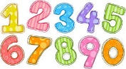
Maths and Numeracy | Humanities | Science and Technology | Health and Well-being | Expressive Arts
Collect a variety of natural objects – sticks, stones, leaves etc. Make a tally chart using the objects you have found. What did you find the most of?  Could you show this information in another way? Try using J2Data on Hwb.  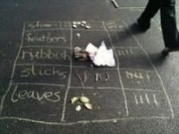 | Watch the clip to learn about the water cycle. https://www.bbc.co.uk/bitesize/topics/zkgg87h/articles/z3wpp39  Imagine you are a droplet of water, act out your journey. Encourage everyone in your house to play a part! Or how about drawing a cartoon to explain the water cycle to your family? | Have a go at making magic flowers!  https://www.youtube.com/watch?v=8-_-fNyeQpI | Do something daft! Maybe create an obstacle course with toilet roll. Tape zig zag lines across a hallway. Try to get through without breaking the paper!  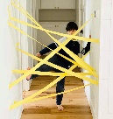  Or how about an obstacle course using things from around the house? HAVE FUN!! | 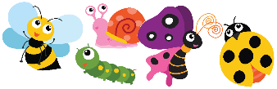  Search your outdoor space for mini beasts. Make a painting, drawing or even a junk model of your favourite one.
Home-School Activities - Summer Term 1

