YEAR 2  Date – Monday 27th to Friday 8th May (2 weeks) |  | Here are your tasks for the next two weeks. It’s up to you what order you do them in. Enjoy and stay safe!
Language, Literacy and Communication | Language, Literacy and Communication | Language, Literacy and Communication | Maths and Numeracy | Maths and Numeracy
Instruction Writing  What are you good at? It could be cooking, gardening or football skills. Choose an activity and write instructions for a member of your family. Use this link to help you – watch bossy verbs and look at activity 2.  https://www.bbc.co.uk/bitesize/topics/zpbbkqt/articles/zbv72sg  Templates on twinkle to help you set out your instructions. | Watch these phonics clips -there are two clips for each sound. Write down the words that Geraldine finds. How many can you spell without looking? Have your own word hunt around the house! Can you find any of the words in a book?  https://www.youtube.com/watch?v=W1xqLjHF53A  https://www.youtube.com/watch?v=VpTIpkgU1fY | Using the handwriting guide, write out the cursive alphabet. You could use pencils, pens or chalk. Can you write the alphabet forwards and backwards?  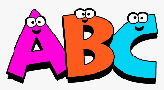  Extra Challenge!  Now write out your tricky spelling words cursively? How about trying the days of the week? Months of the year? Number words? | 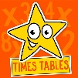  Have you been working on your times tables? Can you invent a game to test your skills? Maybe a board game or card game? What will you get if you get the answer right or wrong?  Have fun teaching your family to play your game! | Work on your number skills. Use this game to find numbers and to use your mental maths skills. https://www.topmarks.co.uk/learning-to-count/blast-off  Try this game if you would like a challenge! https://mathsframe.co.uk/en/resources/resource/289/KS2_Maths_Invaders  You can use the arrows to select different skills.
Maths and Numeracy | Humanities | Humanities | Health and Well-being | Expressive Arts
Problem Solving! Can you help Noah solve this problem?  https://nrich.maths.org/content/id/7210/NRICH-poster_Noah.png  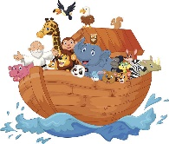 | 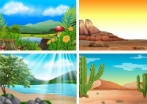  Research an environment: jungle, dessert, forest, beach, or underwater. Can you create your own mini environment using lego, junk materials, clay, play dough, or paper? | Can you make a boat out of tin foil? How many pennies can it hold while floating? How could you make it stronger? Now try making a foil boat that moves!  https://www.stem.org.uk/system/files/elibrary-resources/legacy_files_migrated/628-Making%20a%20Moving%20Foil%20Boat.pdf | Using the Jasmine active log in complete lesson  7, 8 & 9 – The Jungle Environment.  Home.jasmineactive.com  Email: parent@tremainspr-1.com  Password: tremainspr | Gather resources on your daily walk, from the garden or around the house and create a picture inspired by Welsh environmental artist Tim Pugh. https://www.timpugh.co.uk/gallery1  