Date – Monday 27th to Friday 8th May (2 weeks) | Mr Maybery & Mrs Kingston N – Y2 |  | Here are your tasks for the next two weeks. It’s up to you what order you do them in. Enjoy and stay safe!
Language, Literacy and Communication |  | Language, Literacy and Communication | Maths and Numeracy | Maths and Numeracy | Science and Technology
https://www.oxfordowl.co.uk/for-school/oxford-owl-ebook-collection  Choose an age appropriate story for your child. Listen to the story with them. Use the ‘Tips for reading’ on the inside page to discuss the story. Complete the interactive activities. |  | Play a game of ‘I Spy’ in the house, garden, or on your walk.  Here are some ideas you can use to make it easier or harder.  I Spy…..Objects e.g. ‘I spy a…..Tree’  I Spy something Big/Small/long/short.  Colours – I spy something green’  Initial sounds. ‘I spy something beginning with t’  Rhyming words. ‘I spy something that rhymes with bat’ | Fun with shadows-use chalk to draw around shadows or use a piece of paper and pencils. Draw around your family’s shadows and measure each one. You can use hand spans, steps, string or a tape measure. Find out who has the tallest/ shortest shadows? Are the shadows the same size as each person?  You could do this with other objects too- toys, plants etc | https://www.topmarks.co.uk/Search.aspx?Subject=16&AgeGroup=1  Choose your favourite counting games from the Topmarks website. | Can you use different materials to make a bird feeder?  See some of the examples attached for inspiration.
Science and Technology |  | Humanities | Health and Well-being | Health and Well-being | Expressive Arts
Take some photos of any birds that visit your bird feeder. You could share them on our Facebook group or tweet them and tag school in the photos for us to see. |  |  | Can you work through a Sensory Circuit? 4 different stations. 1, Push & pull – row your boat with an adult or sibling. 2,follow a zig-zag balance line made from masking tape, or pebbles in the garden. 3, 10 star jumps. 4, ‘Press ups’ against the wall. |  | Use any resources you like to create a wonderful picture from Mother Nature. This could be a rainbow, a picture of a favourite animal, a scene from a walk – anything.  You could use Jit5 on Hwb, use paint/collage materials, drawings/colourings. Lego/building equipment .  https://hwb.gov.wales/
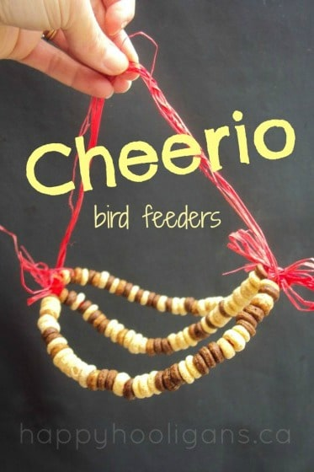
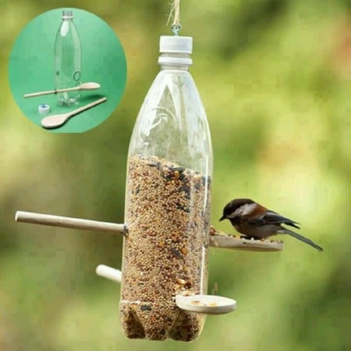
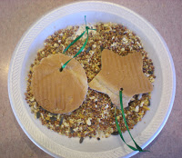
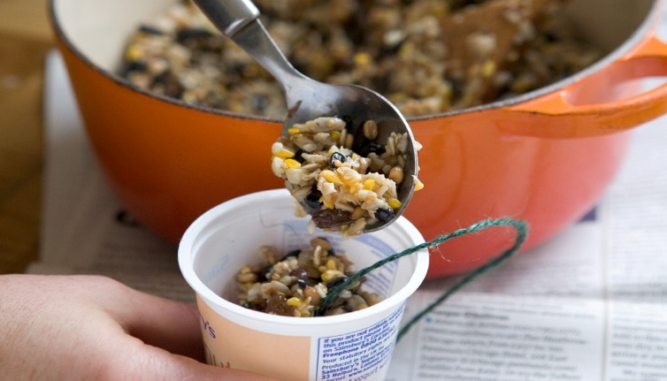
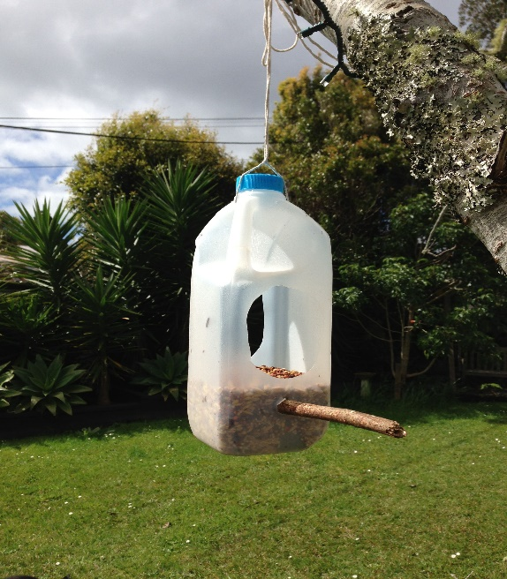
Bird Feeder Ideas
Stale bread
Homeschool Activites - Summer Term 1

